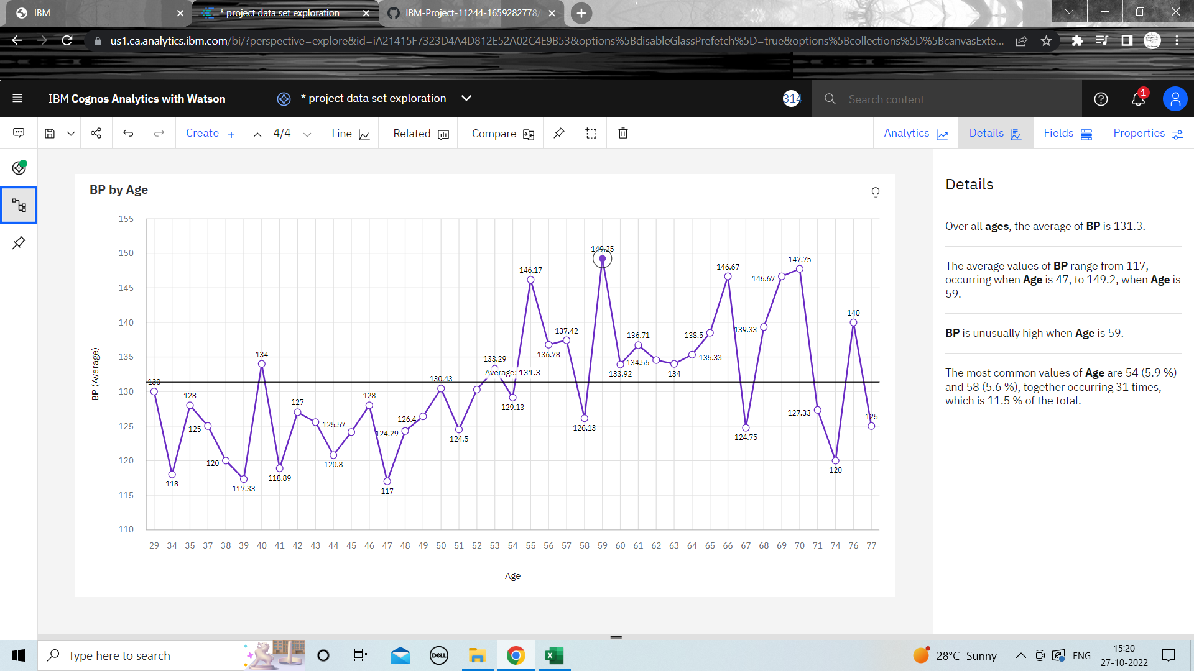**Exploration of Blood Pressure vs Age**